Week 3 Partial Solution
Participation Dates

For a retirement plan, the participation date is the date when an employee can become a participant of the plan. The participant of the plan then begins to accrue benefit service that is used to determine his various benefits (say, retirement benefits, termination benefits, etc.) and his eligibility for those benefits on his participation date.

We will build an Excel model that calculates participation dates, based on a few common plan provisions for defined benefit plans in the United States, as shown below.

- One-year anniversary of the employment
- The first day of the month on or following one-year anniversary of the employment
- The first day of the month on or following one-year anniversary of the employment and 21st birthday
- The first day of the year on or following one-year anniversary of the employment
- The first day of the year on or following one-year anniversary of the employment and 21st birthday
- 1/1 or 7/1 of the year on or following one-year anniversary of the employment
- 1/1 or 7/1 of the year on or following one-year anniversary of the employment and 21st birthday
In the above, 1/1 means January 1st and 7/1 means July 1st. Let’s demonstrate a couple of examples, based on the plan provision “1/1 or 7/1 of the year on or following one-year anniversary of the employment” below.
- If the hire date is 7/3/2013, then the first anniversary is 7/3/2014. Since it is neither January 1st nor July 1st, the participation date should be 1/1/2015.
- In comparison, if the hire date is 7/1/2013, then the participation date should be 7/1/2014.
We can see that the participation date is usually dependent on either date of birth or date of hire. So, we will have these two dates (date of birth and date of hire) as our model inputs in our model. We have these two input dates in cells D5:D6. The cell D5 is the input for Date of Birth while the cell D6 is the input for Date of Hire.

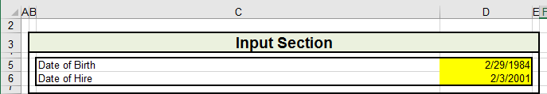

The formula for “One-year anniversary of the employment” is in cell D10. We can use the EDATE function to get the formula easily as shown below,

=EDATE($D$6,12)

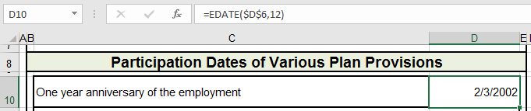

If the hire date falls on February 29th, the one-year anniversary will fall on February 28th. People may argue, “Should the one-year anniversary be on March 1st?” We will not judge whether it should be March 1st or February 28th here. If the plan document does not specify, plan administrators may have the authority to interpret it according the plan’s standard practice and policies. Depending on the interpretation, the formula might change slightly.

Most plans define its participation date to be on the first day of the month. Our approach for the second plan provision (The first day of the month on or following one-year anniversary of the employment) is to determine the end of the month of one year anniversary and then add one day to it to get the first day of the following month. But we have to make sure that if the hire date falls on the first day of the month, we will use the end of the previous month instead. The concise formula in D11 below will do the trick, which takes the full advantage of the function EOMONTH.

= EOMONTH(D10-1,0)+1

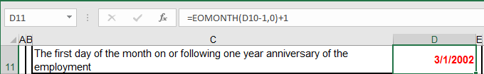

Once this formula is finished, you have to test whether the model produces a right participation date if the input date of hire falls on 2/29 of a leap year. You should always check the extreme cases.

Cell D12 is for “The latter of one-year anniversary of the employment and 21st birthday”. The formula in cell D12 is straight forward, as shown below,

= MAX(EDATE(D5,12*21), EDATE(D6,12))

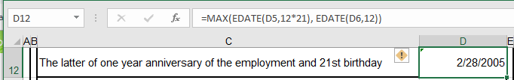

As you can see, we keep 12*21, rather than the final calculated number of months. The subtle difference between the two allows checkers to confirm the formula easily.

We can then copy the formula in cell D11 and paste it in cell D13 to get the provision of “The first day of the month on or following one year anniversary of the employment and 21st birthday”. The final formula is shown below:

=EOMONTH(D12-1,0)+1

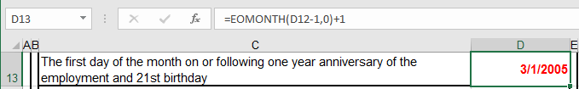

For provision “The first day of the year on or following one-year anniversary of the employment”, you may build one formula in one cell. Since we have calculated certain dates in cells D10:11, we are going to use the results in those two cells and get the formula below in cell D14:

=IF(MONTH(D10)=1, D11, DATE(YEAR(D11)+1,1,1))

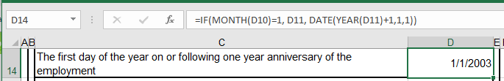

It is a possible there is a simpler formula than above, but we do not try to figure that out. The formulas in cells D15:D17 for the last three plan provisions are all similar to the previous formula, which means we will need to use IF functions to branch the calculations. These formulas are a little bit long and shown below:

=IF(MONTH(D13)=1, D13, DATE(YEAR(D13)+1,1,1))
=IF(OR(MONTH(D11)=1, MONTH(D11)=7), D11,
IF(MONTH(D11)<7, DATE(YEAR(D11),7,1), DATE(YEAR(D11)+1,1,1)))
=IF(OR(MONTH(D13)=1, MONTH(D13)=7), D13,
IF(MONTH(D13)<7, DATE(YEAR(D13),7,1), DATE(YEAR(D13)+1,1,1)))

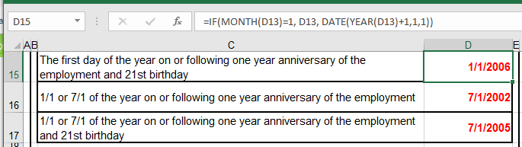

That would conclude the model for the participation dates.

Here is what our finished model looks like on Excel.

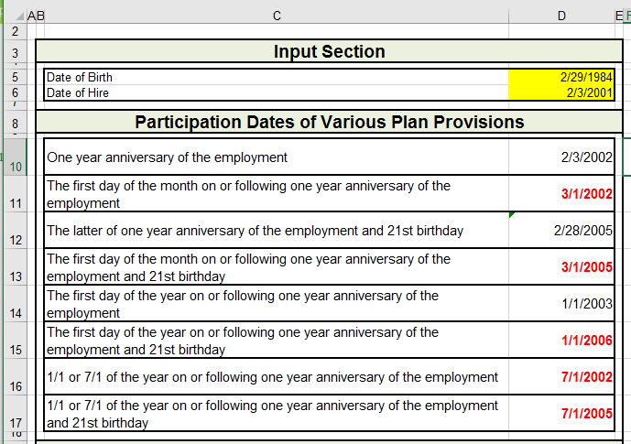

But before you can claim that you have finished the assignment, you have to go through the Page Layout to set up proper printout formats and footer.

